Crowd Size Management

Priyam Chauhan (6)
Computer Engineering
San Jose State University
San Jose, USA
priyam.chauhan@sjsu.edu
Manish Katturu (15)
Software Engineering
San Jose State University
San Jose, USA
manish.katturu@sjsu.edu

Abstract—The idea presented in this paper is to monitor and manage the number of people in the certain areas that can be offices, social events, or any other place. Sometimes the need arises to keep the restriction on the number of people that can be together in the confined space, taking the current COVID-19 scenario as an example. To operate some businesses and gatherings considering the guidelines for safety of people, it becomes necessary to keep some limits and monitor it in timely manner. Hence, here, the system is set that captures the data like number of people through Pi Camera Module in configuration with Raspberry Pi 4B by using OpenCV and Python which is then fed into ThingSpeak channel. There is a counter of number of people set in the ThingSpeak channel which can be monitored from anywhere in the world. If the number exceeds a pre-decided limit, then the warning can be given. So, that there will be less crowd and safety is maintained considering social distancing.
Keywords— crowd size, Raspberry Pi 4B, Pi camera module, OpenCV, ThingSpeak, Python

Introduction
In the present scenario of COVID-19, many of social gathering places need to follow social distancing to control the spread of COVID-19. As a result of which people are restricted at various locations in the city but it becomes tedious task to manage the crowded areas where a number of people roam around. So to manage the number of people in a particular area, our project “Crowd Size Management” provides a solution by using IoT devices to collect the data in regular intervals of time about the number of people in an area. This helps to control the flow of people at the surrounding locations. Also, our project collects time to time data of Crowd Size in an area which can help to predict the future traffic and make all the required arrangements. It also helps to monitor highly affected zones due to COVID-19 and prevent the outbreak from that particular region. Particular areas like airport, restaurants and shopping malls requires high attention to maintain social distancing among the people, where our project is of top requirement.

Methodology

Objective
The objective of “Crowd Size Management” is to get the counter of number of people in the selected area of any place like offices, event centers, social gatherings, or any public location. The main objective is considering the current scenario of COVID-19 and applying these concepts for that. There are certain restriction and guidelines put for the people’s safety to minimize the spread of coronavirus. And one of them is to keep limits on the number of people in the place together. So, this idea can be used there, and it can work for monitoring and alerting if the crowd size increases.
The data frames are captured through the Pi Camera Module in the configuration with Raspberry Pi 4B connected to the Wi-Fi. Then the data frames are processed with “Histogram of Oriented Gradients (HOG)” to detect the objects, here people, in the images. After this, the data frames are compared with the pre-trained model of OpenCV for detection of people. Here, the programming is done using Python language. This counter will be updated and shown on the channel of ThingSpeak, which is an open-source Internet of Things. And then monitoring can be done on any device with internet connection. The Architecture is shown in the Figure 1.

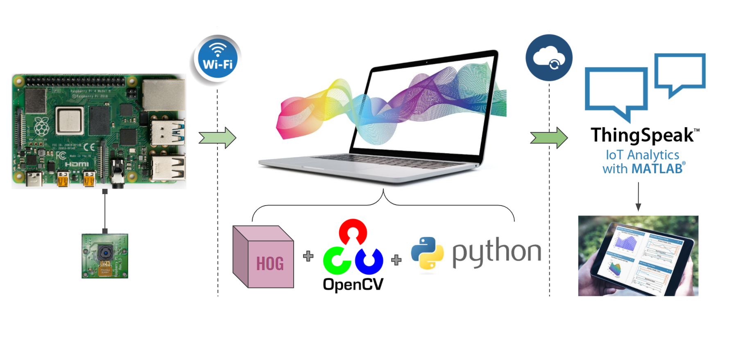
Figure 1: Architecture and Flow

Flow of the Process
The steps followed in the whole process are as follows as shown in the Figure 2.

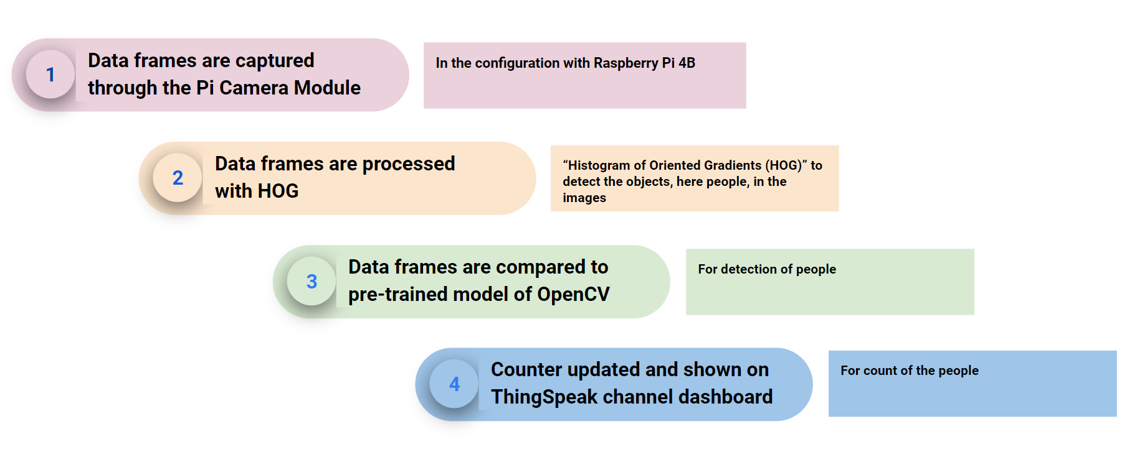

Figure 2: Flow of the Process

- Data frames are captured through the Pi Camera Module, in the configuration with Raspberry Pi 4B.
- Data frames are processed with HOG to detect the objects, here people, in the images.
- Data frames are compared to pre-trained model of OpenCV.
- Counter updated and shown on ThingSpeak channel dashboard.

Implementation
In this section, we have described various hardware and software components used in this project.

Hardware Design
The following are the major hardware components used in the project:
    - Raspberry Pi 4B
The Raspberry Pi is a low cost, card sized computer that plugs into a computer monitor or TV and uses a standard keyboard and mouse. Its capability includes mostly everything one might expect a desktop computer to do. For example from browsing the internet, playing high-definition video, to making spreadsheets, word-processing, and playing games which enables people of all ages to explore computing, and to learn how to program in languages like Scratch and Python. We have used Raspberry Pi 4B model for this project.

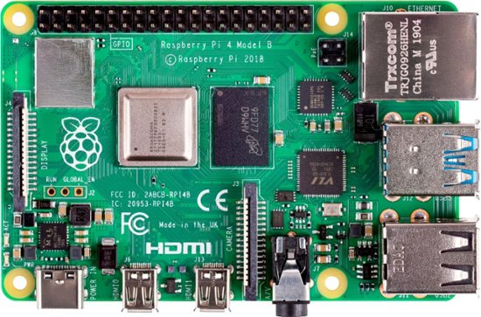
Figure : Raspberry Pi 4B Model

Specifications:
Processor: Broadcom BCM2711, quad-core Cortex-A72 (ARM v8) 64-bit SoC @ 1.5GHz
Memory: 2GB, 4GB or 8GB LPDDR4 (depending on model)
Connectivity: 2.4 GHz and 5.0 GHz IEEE 802.11b/g/n/ac wireless
LAN, Bluetooth 5.0, BLE
Gigabit Ethernet
2 × USB 3.0 ports
2 × USB 2.0 ports.
GPIO: Standard 40-pin GPIO header (fully backwards-compatible with previous boards)
Video & sound: 2 × micro HDMI ports (up to 4Kp60 supported)
2-lane MIPI DSI display port
2-lane MIPI CSI camera port
4-pole stereo audio and composite video port
Multimedia: H.265 (4Kp60 decode);
H.264 (1080p60 decode, 1080p30 encode);
OpenGL ES, 3.0 graphics
SD card support: Micro SD card slot for loading operating system and data storage
Input power: 5V DC via USB-C connector (minimum 3A1)
5V DC via GPIO header (minimum 3A1)
Power over Ethernet (PoE)–enabled
(requires separate PoE HAT)

    - Pi Camera Module
The Pi Camera Modules are official products from the Raspberry Pi Foundation and is a portable light weight camera which supports Raspberry Pi. It communicates with Pi using the MIPI camera serial interface protocol. It is usually used for image processing, machine learning or in surveillance projects like we did here.

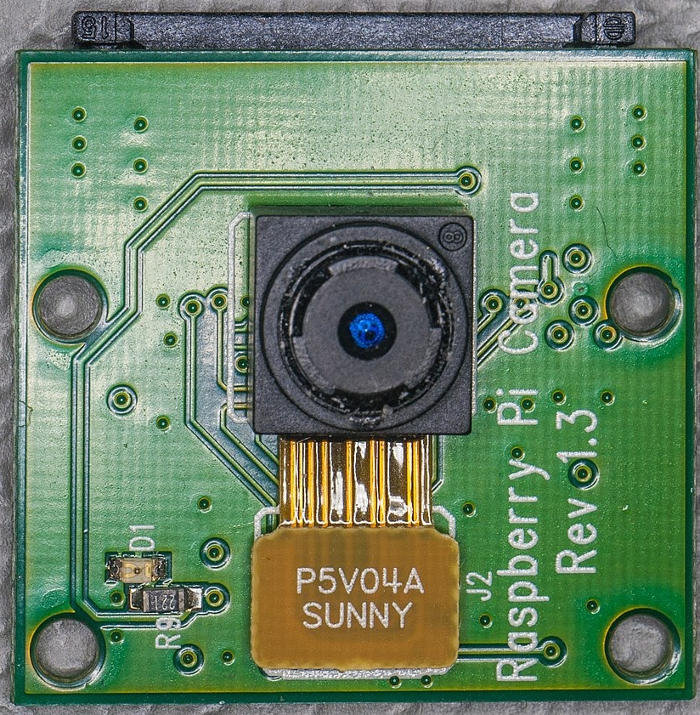
Figure: Pi Camera Module

Specifications:
2592 x 1944 Pixel Static Images, 1080 p @ 30 fps, 720 p @ 60 fps and 640 x480 p 60/90 Video Recording, 5 Megapixel sensor OV5647
For using Pi Camera, one needs to enable camera support using the raspi-config program which is used when setting up Raspberry Pi for the first time. Use the cursor keys to select and open Interfacing Options, and then select Camera and follow the prompt to enable the camera. Upon exiting raspi-config, it will ask to reboot.

Software Design
Software is an integral part of this system because it connects all the module and act as the communication channel between each module. The major components and libraries are explained below:

OpenCV 3.0
OpenCV (Open Source Computer Vision Library) is a library of programming functions with the aim at real-time computer vision. The library is cross-platform and free for use under the open-source Apache 2 License and it has features like GPU acceleration for real-time operations.
OpenCV library will be used to detect the crowd. Steps to install the OpenCV are as follows:
- Update the Raspberry Pi.
- Install the required dependencies for installing OpenCV on your Raspberry Pi.
- Install the OpenCV in Raspberry Pi.

ThingSpeak
“ThingSpeak is an open-source Internet of Things application and API to store and retrieve data from things using the HTTP and MQTT protocol over the Internet or via a Local Area Network.”
We have created a channel on ThingSpeak, and we are uploading the captured data frames on these analytics platform every 15 seconds to generate real-time data analytics charts and give the counter of number of people.

Python
We have used Python Programming language which is an interpreted, high-level, and general-purpose programming language and mainly emphasizes on code readability

Testing and Verification
In order to ensure that all the components and sensors are working, we performed unit testing of all our circuit components. The images collected by the pi camera are cross verified with the image shown in front of the camera. We Tested the image data in regular intervals of time and the image data on the LCD screen matched well with the image in front of the Pi camera. Also, the images collected from the pi camera are sent to the laptop through raspberry pi. Raspberry pi is tested connecting it to the LCD screen via HDMI cable to gain access to the Raspbian OS. Raspberry pi is connected to Wi-Fi and the connection to Wi-Fi is verified by executing “ipconfig” command on the windows command line. Access to raspberry pi from the laptop is checked using Putty tool where the IP address of the raspberry pi is used as host in the Putty and gain access to the raspberry pi terminal.
We performed integration testing by connecting all components of the circuit and the power supply. Pi camera is connected to CSI connector of the raspberry pi 4 using short ribbon cable. Power supply is provided to Raspberry Pi 4 with USB-C power cable. 16GB-SD card with Raspbian OS and the Wi-Fi connectivity files is inserted into Raspberry Pi 4B memory slot to boot OS from the memory card on Raspberry pi. Images from Pi camera are sent to raspberry pi and processed for crowd Size detection in Raspberry Pi. By changing the testing conditions in raspberry pi, LCD screen refreshes and displays new output(fresh captured image) in every 5 seconds. Also, the detected crowd size data is uploaded to ThingSpeak IoT cloud platform through Wi-Fi module. Data displayed on the ThingSpeak application dashboard matched with the LCD displayed values. The application is tested by setting a regular time interval to read and upload data to ThingSpeak. The readings on the ThingSpeak matched well with the data shown on LCD screen.

Sr. No. | Components | Notes
1. | LCD screen/monitor | Displays Pi Camera captured images and Raspberry pi screen.
2. | Raspberry Pi 4B | Used to send the data from Pi camera to the LCD screen and ThingSpeak cloud platform.
3. | Pi Camera | Used to capture images and send it to the LCD screen.
4. | USB Power supply | Connects Raspberry Pi 4 to the power supply.
5. | HDMI Cable | Connects Raspberry Pi 4 to the LCD Screen.
6. | 16GB SD Card | Contains Raspbian OS and connected to Raspberry Pi 4 to boot OS on it.

  - Results
For this project, we got the result as shown below:


Figure: Actual image with two people
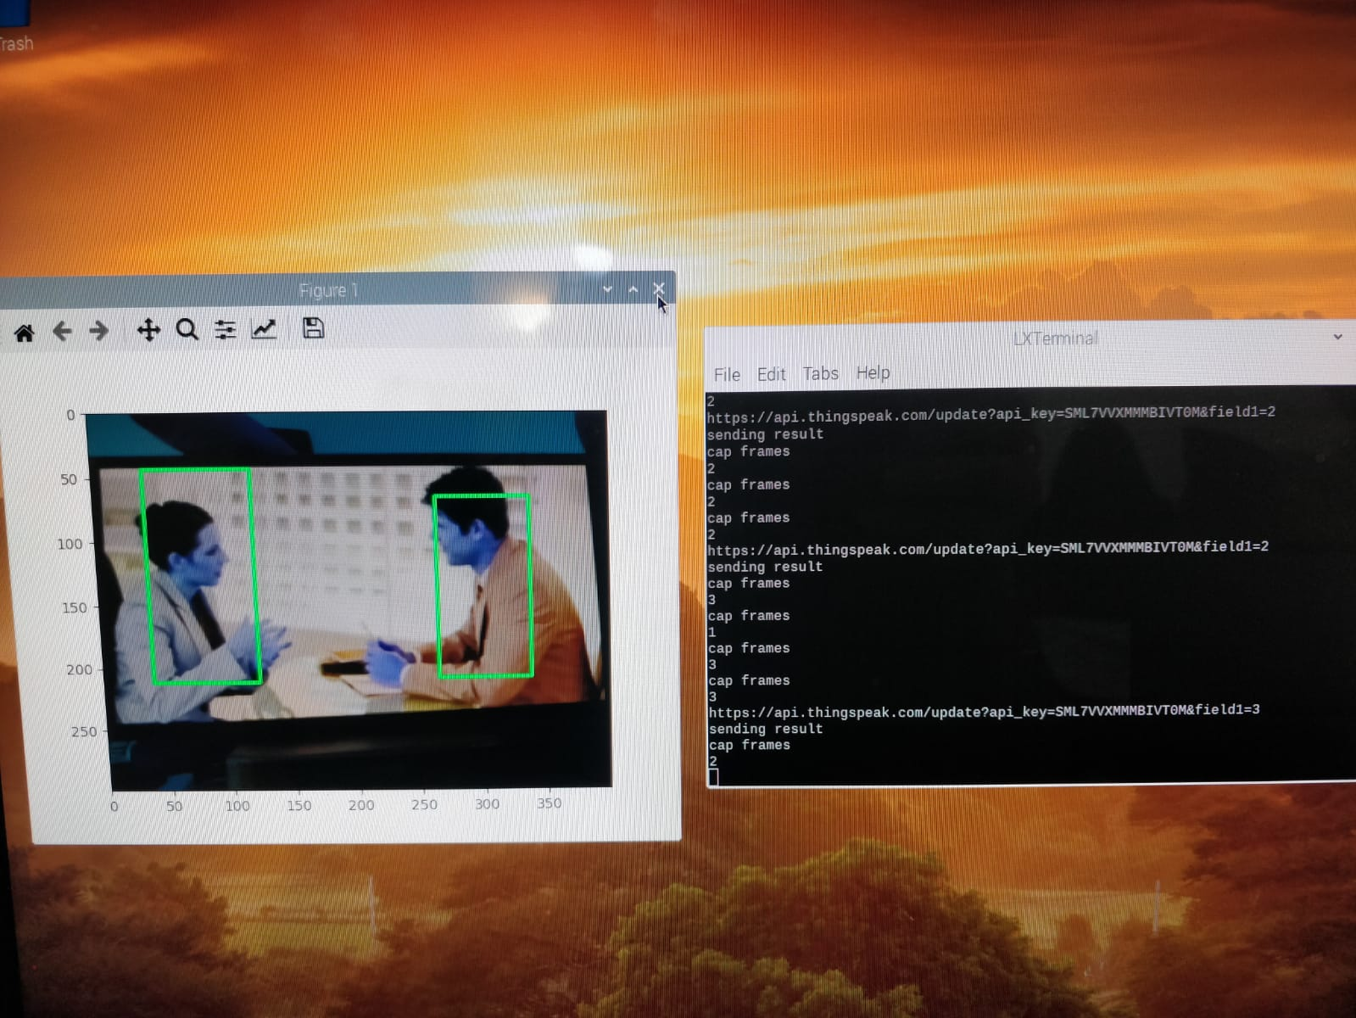
Figure: Detection through Pi Camera and Counter on screen

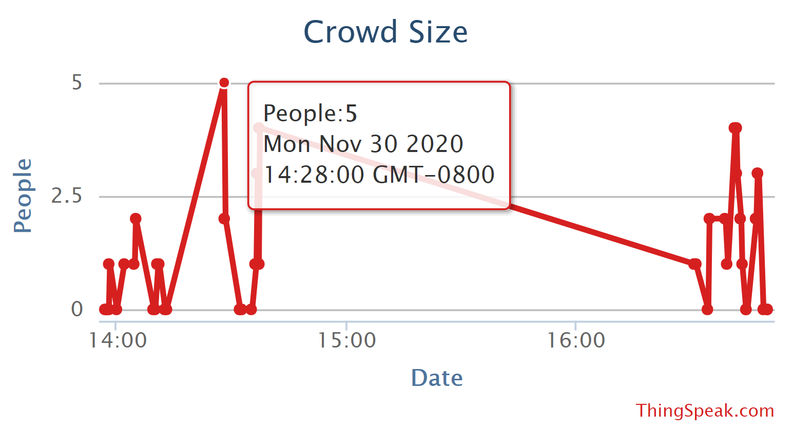
Figure: ThingSpeak Graph results for two people

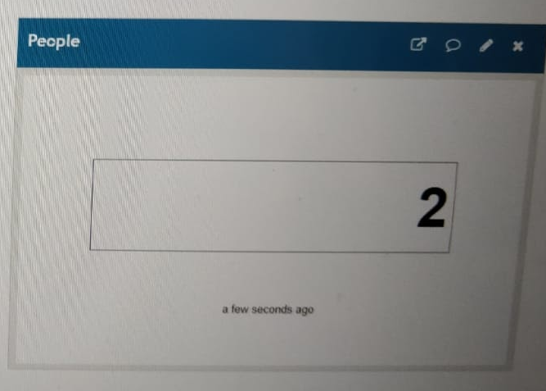
Figure: ThingSpeak Counter results for two people


Figure: Actual image with five people

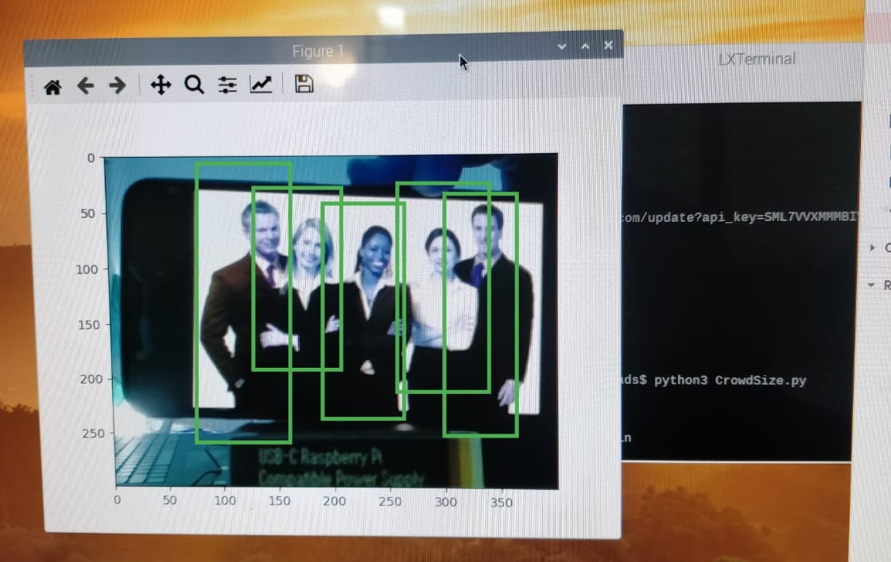
Figure: Detection through Pi Camera and Counter on screen

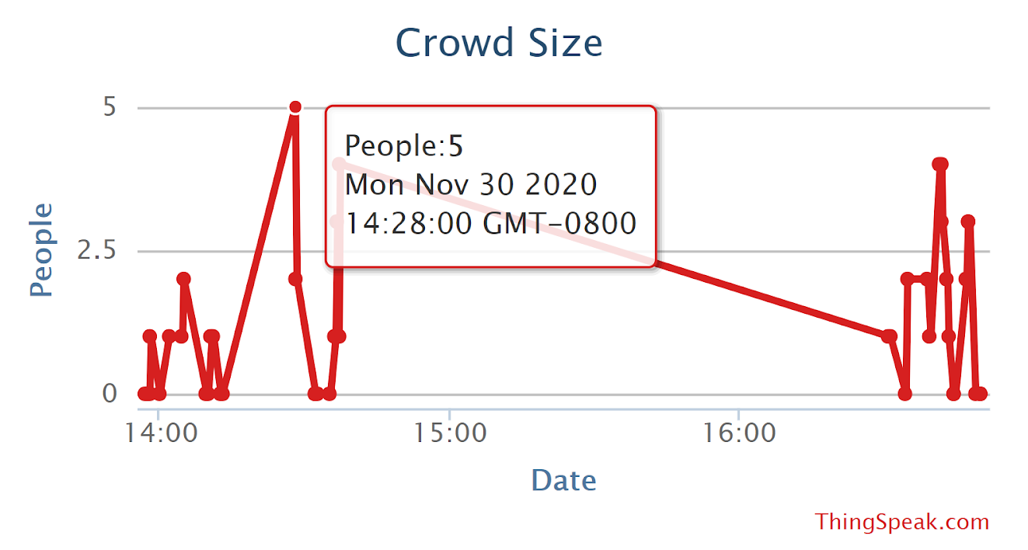
Figure: ThingSpeak Graph results for five people

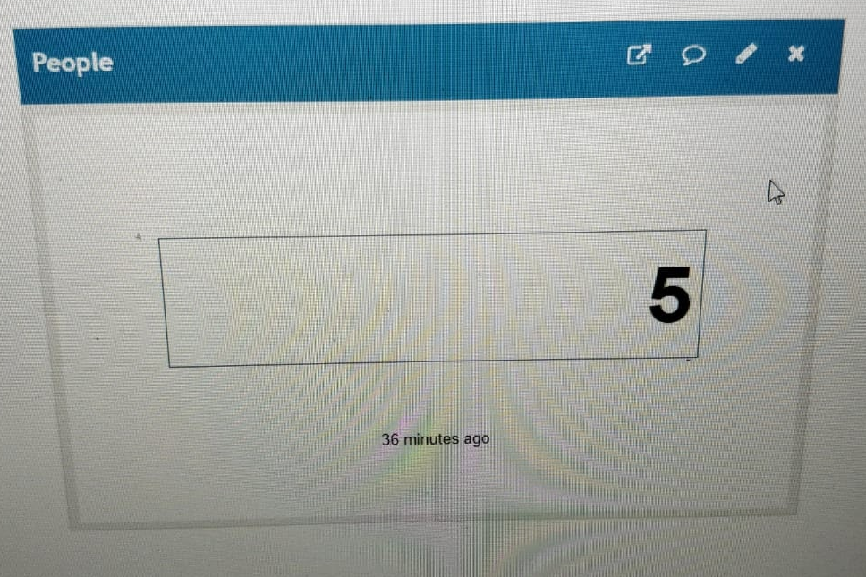
Figure: ThingSpeak Counter results for five people

Conclusion
This project provides a way to monitor the number of people in an area and manages the crowd size by sending the data to ThingSpeak IoT platform and provides the users with the visualization i.e. data shown in graphs regarding the number of people in an area at a given time. ThingSpeak Dashboard helps the users to easily identify when the Crowd Size goes more than the threshold and take necessary measures to control the traffic in that zone. Also, the data collected and stored for months can be used to predict the future Crowd Size or during a holiday and helps the security to make necessary arrangements to control it and channelize the traffic. The results show that the system detects the number of people in an image which exactly matches with the number of people in the real picture. This project lays the groundwork for building a system that helps to detect people with face masks, This project can be extended by integrating machine learning models to identify people with firearms in an area and control the crime rate. Also, as this project is WiFi connected, can be implemented in any open area to monitor the traffic.

Future work
We can combine this project with the ‘Face Mask Detection’ and make it work as a whole system for COVID-19 to check on the people if they are maintaining the limited crowd size or not with their mask on.

Acknowledgment
We would like to thank Dr. Ammar Rayes for giving us this opportunity to work on this project and providing us with proper guidance about the how IoT plays its role in various fields and how it works.

References
- https://circuitdigest.com/microcontroller-projects/crowd-size-estimation-using-opencv-and-raspberry-pi
- https://www.raspberrypi.org/help/what-%20is-a-raspberry-pi/
- https://static.raspberrypi.org/files/product-briefs/200521+Raspberry+Pi+4+Product+Brief.pdf
- https://en.wikipedia.org/wiki/OpenCV
- https://en.wikipedia.org/wiki/ThingSpeak
- https://en.wikipedia.org/wiki/Histogram_of_oriented_gradients
- https://www.pyimagesearch.com/2019/09/16/install-opencv-4-on-raspberry-pi-4-and-raspbian-buster/

Youtube link
https://www.youtube.com/watch?v=9-mdGNk6liw&feature=youtu.be

Appendix

